Lab 2 Task for Analysis of Algorithm
Name:Umar Ahad Uddin Ahmed Usmani
SAP :60199

Task 1 :
In this we take the list of integer from user and serch them using linear search
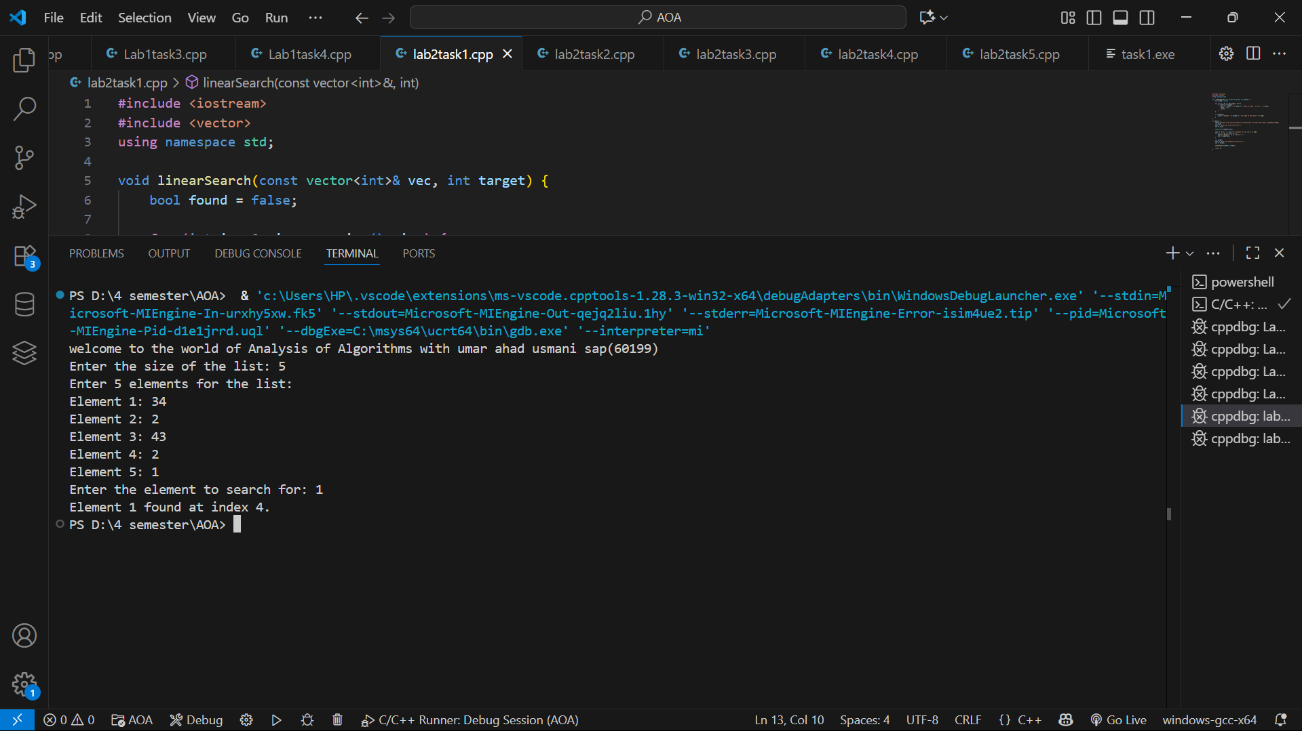

Task 2:
In this task we take the string from the user and ask for enter the pattren that they want to serach and then we use the nested loop and by using this we find the location of the pattren found in the string

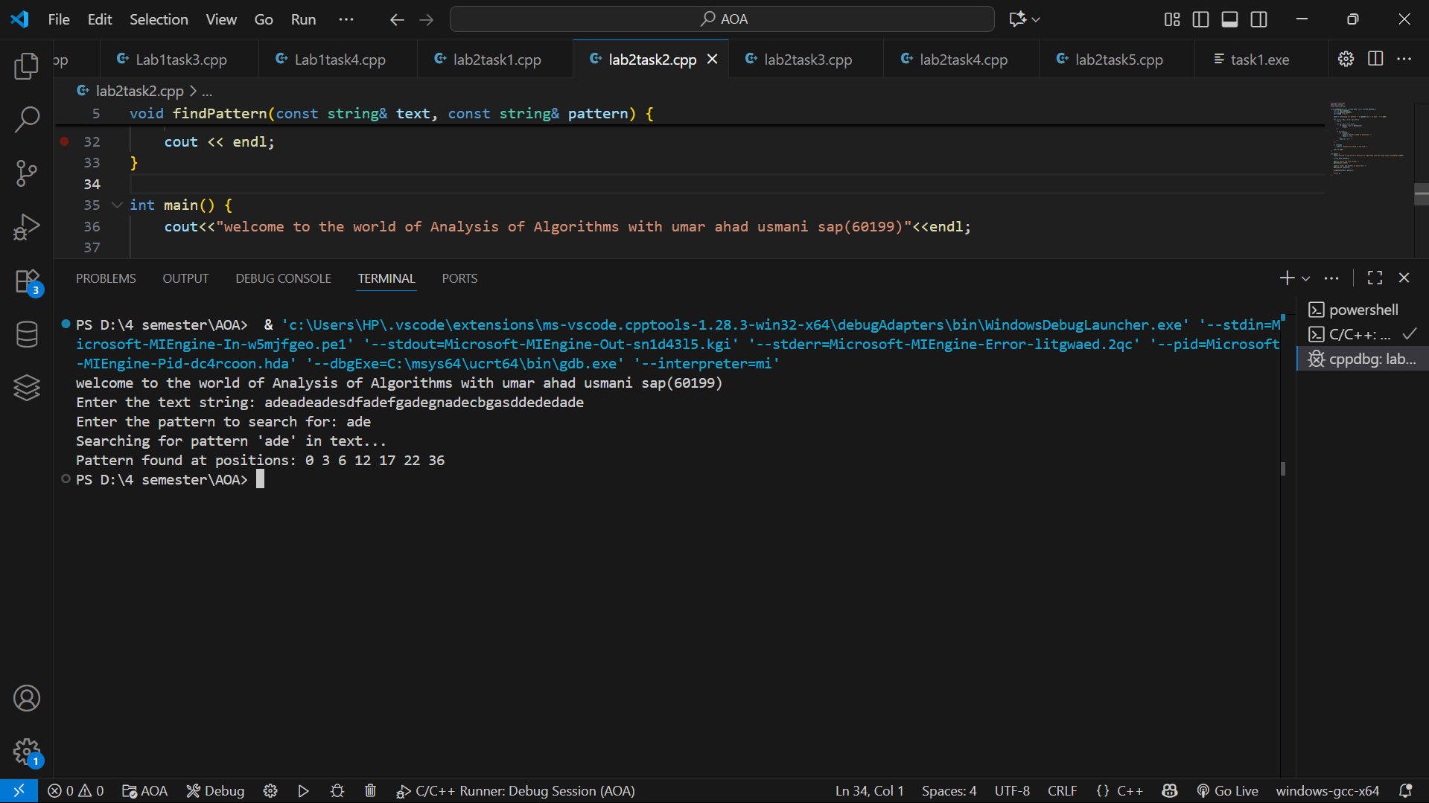

Task 3 :
In this task we take the 3 max digit from user for the passwrod and check the combination and return if the password found from 0 to 9 combination
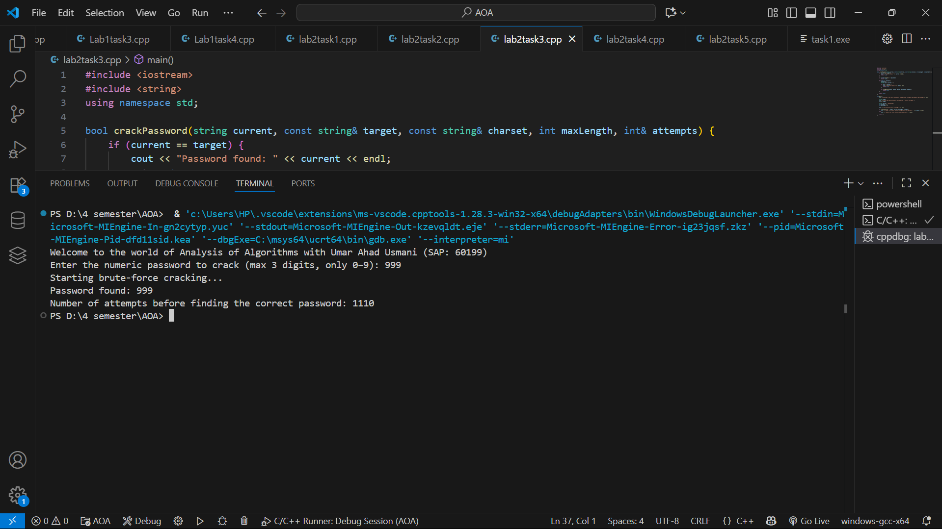

Task 4 :
In this we enter the word and they made the all possible permatation for this word
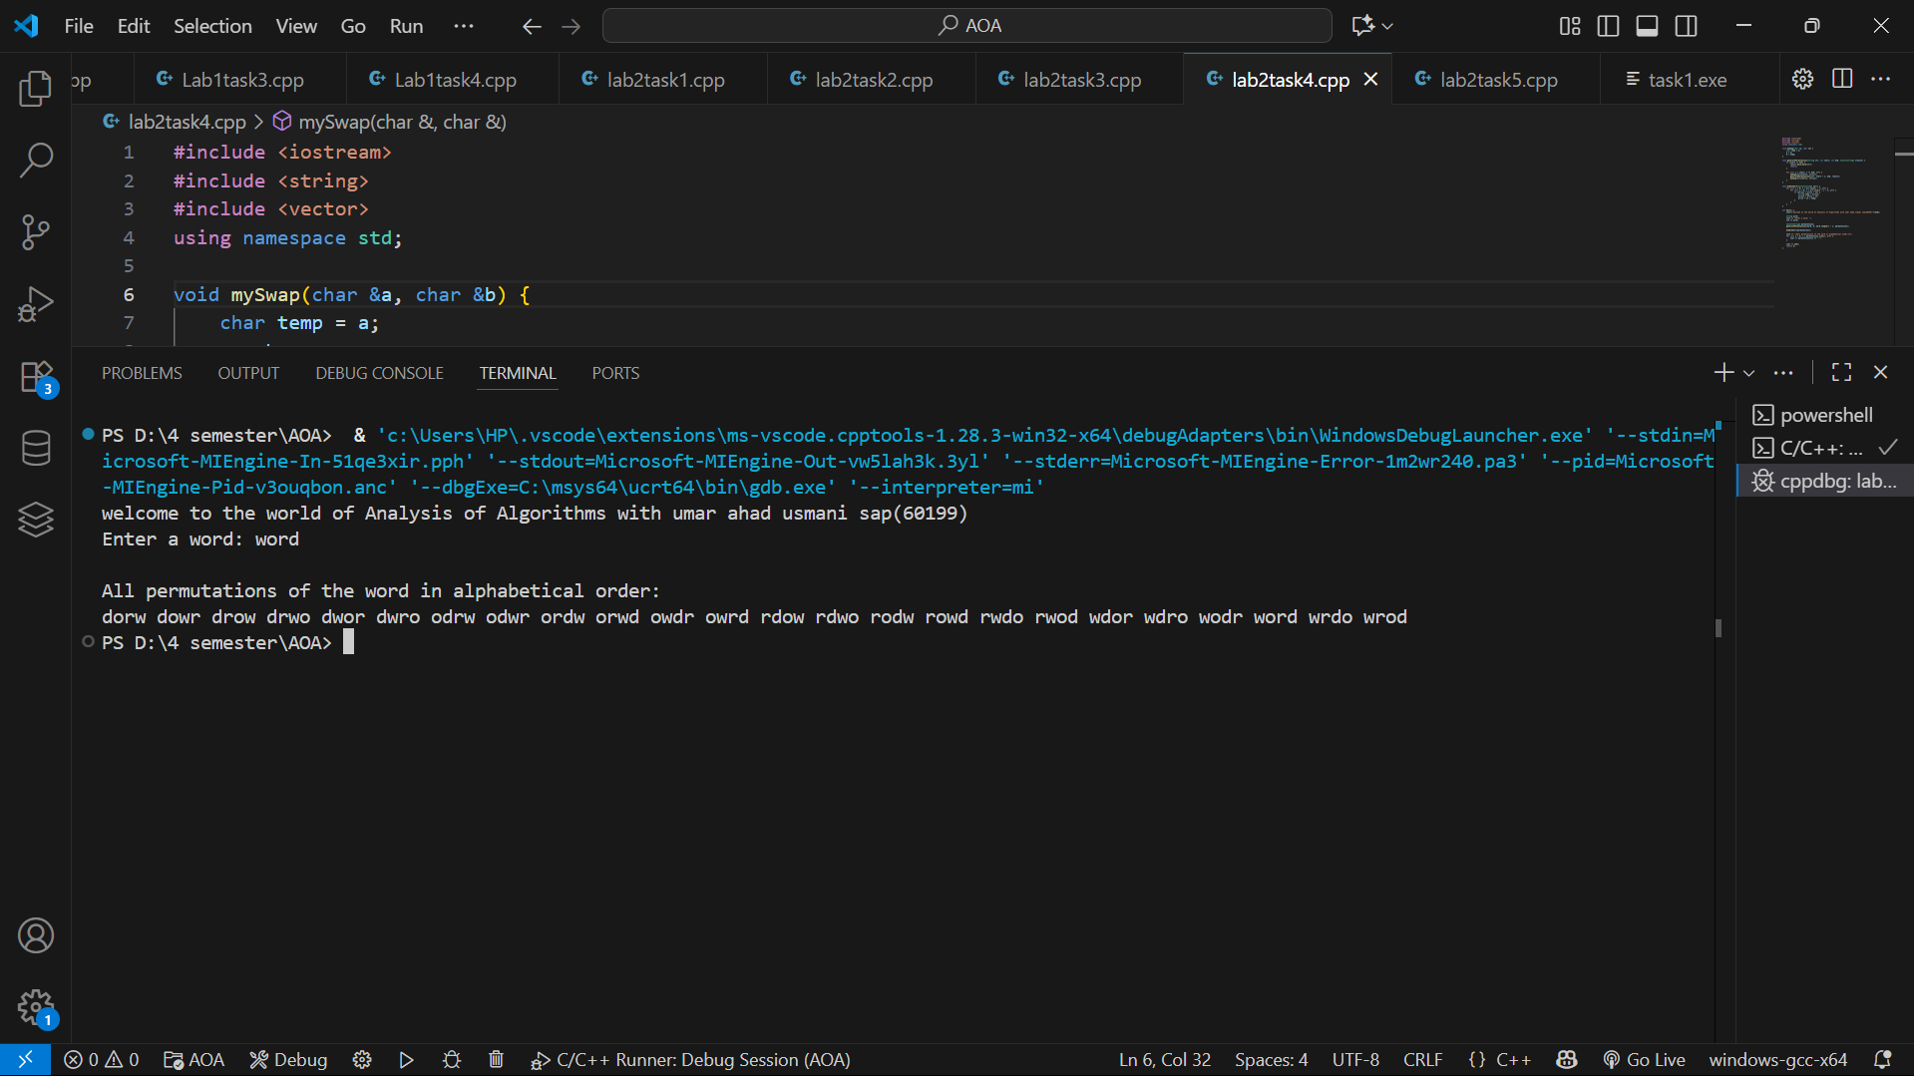

Task 5 :
In this task we take the string from user and they tell the frequncies of character
